Machine-Learning-Guided Design and Experimental Validation of Biofunctionalized Nanodiamonds
Deyani Nocedo-Mena^{1,2*}, Estefania Ascencio^{2,3}, Shan He^{2,3}, Oxana V. Kharissova¹, Romeo Selvas¹, Eduardo Pérez-Tijerina¹, Orestes Boffill Beltrán¹, Sonia Arrasate^{2*}, Humberto González-Díaz^{2,4*}

¹Center for Research in Physical and Mathematical Sciences, Faculty of Physical Mathematical Sciences, Autonomous University of Nuevo León, San Nicolás de los Garza, Nuevo León 66455, México.
²Department of Organic and Inorganic Chemistry, University of Basque Country UPV/EHU, 48940 Leioa, Spain.
³IKERDATA S.L., ZITEK, UPV/EHU, Rectorate Building, nº 6, 48940 Leioa, Greater Bilbao, Basque Country, Spain.
⁴IKERBASQUE, Basque Foundation for Science, 48011 Bilbao, Biscay, Spain.

Table of Contents
S2.1 Computational Section
Conceptual overview of the ND.PTML framework
Data collection and dataset construction
Data pre-processing and descriptor definition
Definition of objectives and reference functions
Perturbation-Theory Operator (PTO) calculation
Training and validation subsets
S2.2 Experimental Section
Sample preparation
Characterization of FNDs
Optoelectronic study
Cytotoxicity assay
S3.1 Machine Learning Results
S3.2 Experimental Results
Annexes
Figure SI_01. Schematic representation of the ND.PTML workflow.
Figure SI_02. Custom-built optical bench used in optoelectronic measurements.
Figure SI_03. Confusion matrices of the optimized Decision Tree classifier for training and validation sets.
Figure SI_04. Correlation heatmap of the ΔDk descriptors used as input variables in the ND.PTML model.
List of abbreviations

S2.1 Computational Section
Conceptual overview of the ND.PTML framework
This section provides an expanded methodological description of the ND.PTML workflow to improve clarity and reproducibility. The structure follows the same order presented in Section 2.1 of the main manuscript.
The ND.PTML (Nanodiamond–Perturbation Theory Machine Learning) framework integrates experimental knowledge with descriptor-based modeling to guide the selection of functionalized nanodiamond systems. In conceptual terms, the workflow combines two complementary elements:
- Reference function: Estimates the expected probability of achieving a desired performance based on previously reported experimental systems under similar conditions.
- Perturbation operators (ΔDk): Quantify deviations in nanodiamond core and functionalizer descriptors relative to reference conditions.
These two elements are integrated into supervised machine learning classifiers that estimate the likelihood of achieving favorable biological or functional outcomes. This perturbation-based strategy allows integration of heterogeneous experimental datasets while preserving interpretability and enabling rational prioritization of candidate nanosystems. For better understanding Figure SI_01 contains a schematic representation of the ND.PTML workflow.
Data collection
The StatNano database (https://statnano.com/) was initially consulted, from which 178 articles containing information about NDs were obtained. The following criteria were considered in the composition of the sample:
Inclusion criteria | Exclusion criteria
Information from research papers | Nanosystems obtained for industrial purpose or others.
Nanosystems formed by nanodiamonds | Incomplete information
Nanosystems obtained for biological intention (for example: bioimaging, environmental, biosensor, drug delivery, etc). | Information from review articles

The dataset includes reported properties of the native NDs (diameter and synthesis method), attributes of the functionalizing agent/coating (Volume, electronegativity, lipophilicity, etc.) as well as reported in vitro experimental data (input parameters). The endpoint used as the result to be predicted is the influence of the functionalizing/doping agent on the bio-application of the FNDs. The data set consisted of 426 rows and 16 columns (15 inputs and 1 output).
Data pre-processing
Data pre-processing is crucial in building an ML model. This process involves transforming raw data into a structured and usable form that can be effectively interpreted by ML algorithms. Typical steps include cleaning the dataset, normalizing or scaling features, creating new relevant features, and dividing the data into training and testing sets. It may also involve eliminating redundant records, handling missing values, or excluding anomalous data points ²⁹.
Raw experimental data were transformed into structured variables suitable for machine learning analysis. Steps included:
- Removal of incomplete or redundant entries
- Standardization of descriptor formats
- Categorization of experimental conditions
- Assignment of descriptor vectors for each nanosystem
Experimental conditions were encoded into a general vector: s_{nj} = [s₀, s_{I}, s_{II}, s_{III} …..s_{nmax}],
representing:
- parameters of biological activity (s₀)
- data quality (s_{I})
- NP type and synthesis method (s_{II})
- functionalizing agent (s_{III})
- coating (s_{IV})
The quality of the data was also defined as categorical variables: Min/Max/Value (q₀), and quality (q₁).
In addition, the database provided molecular descriptors (D_{dk} = [D_{d1}, D_{d2}, D_{d3},..D _{d7}]) to characterize the chemical structure of the FND-based systems. Specifically, we refer to the minimum and maximum diameters of the ND core (D_{d1}, D_{d2}), Van der Waals volume of the functionalizing agent (or coating), as well as the electronegativity, polarizability, the atom contribution to P (lipophilicity (P)) and the average molecular weight of the same. More details about the dataset content can be appreciated in the Supporting Information.
To design the ND.PTML model for functionalized NDs systems, it was necessary to acquire the objective value. We established the target function by employing descriptor vectors for all cases D_{k} as input variables. According to previous studies, the objective function is obtained by mathematical conversion of the theoretical or originally observed feature ^{30–32}. The ND.PTML model involved the observed values, denoted as v_{ij}(c_{d0}). Also, it contained input vectors such as D_{dk} for the functionalizing NDs systems. This dataset was comprised of physical parameters and biological properties. For instance, half the maximum Inhibitory Concentration (IC₅₀ (μg/mL), ζ-potential (mV). The values v_{ij}(c_{d0}) compiled are not exact numbers in many cases. Additionally, to achieve the optimal ND.PTML, we emphasize certain properties while downplaying others. To address this issue, we introduced a “desirability” parameter.
We considered that the properties may have a positive or negative desirability d(s₀). Positive desirability was set d(s₀) = 1 when we want to maximize the value v_{ij}(c_{d0}) of the parameter (this is the case of Fluorescence). Conversely, negative desirability d(s₀) = −1 means that we want to minimize the value v_{ij}(c_{d0}) of the biological activity parameter (for instance IC₅₀ (μg/mL), MIC (μg/mL). These factors complicate regression modeling; therefore, we discretized the outcomes and formulated a classification task. Discretization was as follows: f(v_{ij}(c_{d0}))_{obs} = 1 when v_{ij}(c_{d0}) > cutoff and d(s₀) = 1. The value is also f(v_{ij}(c_{d0}))_{obs} = 1 when v_{ij} < cutoff and desirability d(s₀) = −1, f(v_{ij}(c_{d0}))_{obs} = 0 otherwise. The value f(v_{ij}(c_{d0}))_{obs} = 1 points towards a strong influence of the functionalization or doping on the ND system obtained ³³. Cutoff values were selected based on biological or experimentally meaningful thresholds reported in the respective literature sources. This labeling strategy allows consistent integration of heterogeneous datasets into a unified classification framework.
Table S1. Structure of the ND.PTML dataset and description of input variables.
Variable | Symbol | Type | Description | Source
ND minimum diameter | D1 | Numerical | Minimum nanodiamond core size | Literature¹
ND maximum diameter | D2 | Numerical | Maximum nanodiamond core size | Literature¹
Van der Waals volume | D3 | Numerical | Steric descriptor of functionalizing agent | Database²
Electronegativity | D4 | Numerical | Electronic descriptor of functionalizing agent | Database²
Polarizability | D5 | Numerical | Molecular polarizability descriptor | Database²
Lipophilicity contribution (LogP) | D6 | Numerical | Atomic contribution to lipophilicity | Database²
Molecular weight | D7 | Numerical | Molecular weight of functionalizing agent | Database²
Experimental condition vector | sₙⱼ | Categorical | Encodes assay conditions and methodological subsets | Curated dataset
Desirability | d(s₀) | Categorical | Defines optimization direction (maximize = +1; minimize = −1) | Defined in this work
Observed endpoint | v_{ij}(c_{d0}) | Numerical | value of the experimental conditions | Literature¹
Perturbation-theory operator | ΔD_{k} | Numerical | Describe the influence of the structural and physicochemical deviations of each ND system. | Calculated
Observed outcome class | f(vᵢⱼ)_{obs} | Binary | Favorable (1) or non-favorable (0) performance | Calculated
¹Research papers consulted; ²Atomic physicochemical properties were obtained from the Chemicool Periodic Table database (Chemicool Periodic Table, 2013, Cambridge, MA, USA. http://www.chemicool.com/, accessed February 24, 2017).

Definition of objectives and reference functions
After defining the objective function, the next step was to describe the input variables of the ND.PTML model. These input variables correspond to the reference function f(v_{ij}(c_{d0}), v_{nj}(c_{n0}))_{ref}. The f(v_{ij}(c_{d0}), v_{nj}(c_{n0}))_{ref} is important because this function defines the expected probability f(v_{ij}(c_{d0}), v_{nj}(c_{n0}))_{ref} = p(f(v_{ij}(c_{d0}), v_{nj}(c_{n0}))_{ref} = 1) of getting the desired activity for a particular property from nanosystems. ND.PTML utilizes the reference value from well-known systems or subset systems. Subsequently, this model incorporates the effects of various deviations (perturbations) of the query function from the reference function. Hence, f(v_{ij}(c_{d0}), v_{nj}(c_{n0}))_{ref} may be regarded as a function associated with observed (rather than predicted) results. After obtaining the f(v_{ij}(c_{d0}))_{obs} for all the cases in our dataset, the subsequent step involves quantifying each positive outcome n(f(v_{ij}(c_{d0})) = 1). Then, to derive the reference or expected function, we divide these values by the total number of cases. This function is characterized as: f(v_{ij}(c_{d0}))_{ref} = p(f(v_{ij}(c_{d0}))_{ref} = 1) = n(f(v_{ij}(c_{d0}))_{ref} = 1)/n(c_{n0})_{j} . Then, it can be calculating the reference function directly to find the probability product, expressed as f(v_{ij}(c_{d0}))_{ref} = p(f(v_{ij}(c_{d0}))_{ref} = 1) = p(f(v_{ij}(c_{d0}))_{ref} = 1)).
Perturbation-theory operator (PTO) calculation
The values ΔD_{dk} (c_{dj}) was calculated for each partition (I to IV) representing the respective moving average deviations PTOs. Specifically, these components represent structural descriptors of NDs. More precisely, they are:
D1 = minimum diameter of the NDs; D2 = maximum diameter of the NDs; D3 = average Van der Waals volume of Functionalizing agent; D4 = electronegativity of functionalizing/doping agent; D5 = polarizability of functionalizing/doping agent; D6 = lipophilicity of functionalizing/doping agent; D7 = molecular weight of functionalizing/doping agent.
Next, the perturbation theory operators (PTOs) of ND experimental tests were calculated. Using equation 1 we obtain the Moving Average (MA) of ND systems. The PT model begins with the anticipated value of a well-established activity and encompasses the impact of perturbations or variations within the system. Therefore, the model includes two different sets of input variables: the reference or expected value function (v_{ij})_{ref} and the PT ΔD_{k} (c _{j}) operators, representing structural and assay-related information for NDs.
$$ΔD\left(D_{dk}\right)=D_{dk}-〈{\left(D_{dk}\right)}_{c_{dj}}〉 (1)$$
In addition, the PTO ΔD_{dk} interpret the structural attributes of the NDs and categorize the biological assay data NDs with the variables <(D_{dk})_{cdj} >. The <D_{dk}> represents the average operator to aggregate all cases with the equivalent subset of methodological conditions c_{dj}. Therefore, it is expected to obtain accurate values ​​for a specific assay with at least one element altered in the methodological condition of the vector c_{dj}. Moreover, PTOs directly focused on MA, as well as linear and non-linear transformations of MA, have been utilized in prior research for the prediction of nanoparticle properties ^{5–7}.
Training and validation subsets
Each dataset entry was randomly assigned to:
- Training subset (67%)
- Validation subset (33%)
This stratified division ensures representative distribution of favorable and non-favorable cases.
Model performance was evaluated using:
- Sensitivity
- Specificity
- AUROC
- Classification accuracy
These metrics were used to select the optimal classifier for ND.PTML implementation.
S2.2 Experimental Section
Sample preparation
The extracts were obtained following a traditional phytochemical methodology³⁹. Aerial parts of the medicinal plant Cissus incisa (Nutt.) Des Moul. ex S. Watson were collected in October 2023 in Higueras, Nuevo León, Mexico. The leaves and stems were carefully separated. Fresh plant material was finely chopped and extracted with 250 ml of chloroform/methanol (1:1 v/v) with constant stirring for 24 h at room temperature. The extracts were filtered, concentrated under reduced pressure until complete solvent removal, then allowed to dry at room temperature and stored at 4 °C until later use.
An environmentally friendly green functionalization process was carried out, following methodology previously reported ⁴⁰. NDs (10 mg) and Te (1mg) in 10 mL of double-distilled water were ultrasonicated in Fisher Scientific FS30 apparat (40 kHz, 135 W) for 18 h (in 6 cycles of 3 h), until obtaining the nanosystem=ND-Te. Similarly, the ND-U and ND-Te-U nanosystems were obtained: 10 mg of ND/1 mg of urea, and 10 mg of ND/1 mg of teraphthal/1 mg of urea, respectively. Subsequently, 1 ml of the FNDs was functionalized with 50 μl of each natural extract and ultrasonicated for 1 min. All samples were filtered before characterization.
Characterization of FNDs
Fourier transform infrared spectroscopy (FTIR) was used to characterize the functionalized nanosystems. Thermo Scientific Nicolet iS10 in ATR mode, recording transmittance from 4000 to 500 cm⁻¹ with 32 total scans.
A Horiba Scientific Raman spectrometer (LabRaman HR Evolution) and LabSpec 6 version 7.2 software were used for spectral interpretation (1100 to 1800 cm⁻¹, 3s acquisition time and 5s accumulation, 532 nm laser).
Morphological analysis was performed using a scanning electron microscope (SEM) SU7000 (Hitachi, Japan) operated at an accelerating voltage of 25 kV and equipped with a STEM detector.
X-ray photoelectron spectroscopy (XPS) was used to perform surface chemical analysis of the FNDs. XPS spectra were recorded on a Thermo Scientific Escalab 250Xi with a base analysis pressure of ~10⁻⁸ mbar. A monochromatic Al Kα X-ray source at 1486.6 eV was used.
Particle size distribution and ζ-potential measurements were performed using a Zetasizer Nano ZS (Malvern Instruments, UK). Measurements were conducted in backscatter mode (173°) with an equilibration time of 120 s at 25 °C. Each sample was analyzed in triplicate, and the reported values correspond to the average of three measurements.
Optoelectronic study
A custom-built optical bench system assembled at the Laboratory of Photonics, Universidad Autónoma de Nuevo León (Mexico), was used for optoelectronic characterization (Figure SI_02). A tungsten–halogen lamp (Thorlabs SLS20 IL/M, Globar Light Source; operational range 360–2600 nm) served as broadband light source. The lamp output was coupled to a multimode optical fiber (model M148L01);equipped with SMA connectors, allowing controlled transmission through an adjustable slit within the optical bench setup. Samples were deposited on glass slides and positioned between the light source and the detector. The transmitted signal was collected using a fiber-coupled spectrophotometer (Ocean Optics, model USB 2000+, USA); detection range 200–1000 nm). Absorbance and transmittance spectra were recorded to evaluate characteristic absorption bands and spectral shifts associated with surface functionalization. All measurements were performed in triplicate, and average spectra were used.
Cytotoxic Assay
The CellTiter 96® AQueous One Solution Cell Proliferation Assay (Promega) was used to determine the number of viable cells in the cytotoxicity assays, following the manufacturer’s instructions. 5,000 HaCaT cells (normal human keratinocytes; CLS 300493) were cultured per well in a 96-well plate. Different concentrations of the NPs (6.25, 12.5, 25, 50, and 100 μg/mL) were added, followed by 48 h of incubation at 37 °C with 5% CO₂. Paclitaxel was used as positive control. Absorbance was measured at 490 nm using a 96-well plate reader. All experiments were performed in triplicate in three independent assays. The data were analyzed using the Prism 5.0 statistical software, and IC₅₀ values were calculated by regression analysis ³⁹.
S3.1 Machine Learning Results
After tuning the hyperparameters to optimize the Decision Tree (DT) algorithm, which significantly influences its performance and interpretability, the best combination found was as follows: The “ccp_alpha” parameter was set to 0.0 to prevent excessive pruning and maintain the tree's complexity for optimal classification. The “class_weight” parameter was adjusted to balance the dataset, setting class 0 at 40% and class 1 at 60%, addressing potential class imbalances. It was used “entropy” as “criterion” to evaluate split quality, aiming to reduce impurity at each node.
Additionally, “max_depth” was limited to 6, restricting the tree’s growth to prevent overfitting. The “max_features” and “max_leaf_nodes” were both set to “None”, allowing the tree to explore all available features and leaf node possibilities without additional constraints. The “min_impurity_decrease” was set to 0.0, defining the minimum decrease in impurity required for a split to occur. Additionally, “min_samples_split” = 3 and “min_samples_leaf” = 2, helping balance between capturing meaningful patterns and preventing overfitting. The “min_weight_fraction_leaf” was set to 0.0, indicating it was not applied, while the “random_state” was set to 42, ensuring reproducibility of results across different runs. Lastly, the “splitter” parameter was set to “best”, ensuring that the most optimal split was selected at each node. Similar constraints on depth and split rules have been recommended to balance interpretability and overfitting control in decision-tree-based classification ³⁹.
Model performance was evaluated using standard classification metrics derived from the confusion matrix (see Figure SI_03). The overall accuracy was calculated as:

$$Accuracy=\frac{TP+TN}{TP+TN+FP+FN}$$
where TP, TN, FP, and FN correspond to true positives, true negatives, false positives, and false negatives, respectively.
Using the validation confusion matrix (TP = 55, TN = 50, FP = 22, FN = 14), the accuracy is:
$$Accuracy=\frac{55+50}{141}=0.745$$
Additionally, relationships among the ΔDk descriptor variables were further analyzed using a correlation heatmap (Figure SI_04), which confirms the low multicollinearity within the descriptor space.
Interpretation of Decision Tree classifier
The optimized Decision Tree classifier achieved robust predictive accuracy, with overall accuracy of 0.82 for training and 0.74 for validation set, indicating reliable generalization. Examination of the tree structure revealed that variables such as the minimum and maximum ND core diameter, the Van der Waals volume, and the molecular weight of the functionalizing agents were the most influential features for classification. The prominence of core size descriptors is consistent with established nanodiamond structure–property relationships, where smaller cores provide higher surface-area-to-volume ratios and more accessible reactive sites, directly influencing surface coverage and interfacial interactions ^{1,2}. Likewise, steric and electronic properties of functionalizers (e.g., Van der Waals volume, polarizability, molecular weight) are expected to modulate adsorption/anchoring and aggregation behavior, which are critical for downstream biointerface performance ⁴². These factors directly relate to the physical and chemical interactions that govern stability, surface reactivity, and overall functional performance of the FNDs. This interpretability underscores the practical contribution of the model: identifying which structural and chemical parameters should be prioritized during synthesis to enhance the desired biological or optoelectronic performance. Therefore, the DT results not only validate the predictive framework but also offer practical design guidelines for future FND developments. This is extremely important in ND research, since despite the progress made, significant challenges remain in achieving NDs with essential properties for optimal biomedical functionality ⁹.
The structure of the Decision Tree consists of 19 nodes with a depth of 6, and 20 leaf nodes where final predictions or classifications are determined. For a more detailed interpretation, we have focused on a tree depth of two layers, resulting in three leaf nodes, which collectively form five main families (i, ii, iii, iv, and v). The primary input variables considered in the classification process include ΔD1(sI), ΔD2(sII), ΔD3(sIII), ΔD4(sIV), ΔD5(sI), ΔD6(sII), and ΔD7(sIII). From the results presented in Table 2 (main text), it is concluded that compact or narrowly distributed ND sizes correlate with better predictive outcomes, possibly due to improved surface homogeneity and interaction consistency.
3.2 Experimental Results
The ND.PTML model not only provided accurate predictions for diverse ND-functionalizer combinations but also guided the selection of some systems for practical synthesis. Following these predictions, different samples of hybrid NDs were synthesized, containing teraphthal as a functionalizer and/or extracts of leaves and stems of C. incisa. In total, six nanosystems were obtained by green chemistry: ND-Te, ND-U, ND-Te-U, ND-Te-St, ND-Te-FL, ND-Te-U-St, which were indistinctly characterized. Previously, our group addressed the fluorescent synthesis of similar combinations. Here we focus on application-oriented validation (cytotoxicity and optoelectronics) of these hybrid interfaces.
FTIR spectra (Figure 7A) confirmed the successful functionalization of NDs with urea (ND-U), teraphthal (ND-Te), and their combination (ND-Te-U). This last one sample exhibited overlapping signals characteristic of both compounds, supporting the formation of a hybrid nanosystem with a higher diversity of surface functional groups on the ND. A broad band between 3400–3200 cm⁻¹ is observed, attributed to –OH and –NH stretching vibrations, indicating the presence of surface functional groups introduced by U and Te. This band is more intense in ND-Te-U, suggesting a higher content of these functional groups. This behavior is also detected at 2950–2850 cm⁻¹ region (C–H stretching). In the region around 1700 cm⁻¹, a strong band attributed to C=O stretching confirms the presence of carbonyl groups from carboxylic acids or amides, indicating incorporation of both functionalizers. Additional bands between 1600–1500 cm⁻¹ correspond to N–H and aromatic C=C stretching, characteristic of the benzene ring in Te molecule. Furthermore, the 1400–1000 cm⁻¹ region displayed signals associated with C–N and C–O stretching and aromatic ring deformations, supporting the coexistence of nitrogen-containing and aromatic functional groups, particularly in the ND-Te-U sample.
The ND-Te-FL spectrum ( Figure 7B) showed multiple bands coinciding with the plant extract (FL-ext), especially in the O–H, C=O, C–O and C–N regions, evidencing that the plant metabolites were incorporated into NDs . In addition, new bands or shifts attributable to the presence of the terapthal linker and to possible interactions between the functional groups of the extract and the ND surface are observed. Main bands observed: region 3700–3000 cm⁻¹ (O-H / N-H stretching): in FL-ext it is more marked, is consistent with plant metabolites (polyphenols, flavonoids, etc.). 1750–1600 cm⁻¹ (C=O and C=C stretching): in ND-Te-FL this region persists, although it appears displaced and modified, suggesting interaction or anchoring of carbonyl/conjugated compounds to the FND. 1450–1200 cm⁻¹ (C–H, C–O, C–N bending and stretching): C–O stretching of alcohols or esters, C–N of possible secondary amines or nitrogenous compounds, their presence in ND-Te-FL indicates transfer of functional groups from the extract. Intense region 1100–1000 cm⁻¹ (C–O, C–N, C–OH) assigned to alcohol groups, ethers, or phenolic compounds. The persistence in the Te-FL ND suggests effective incorporation of functional metabolites into the ND surface. Bands at ~880–600 cm⁻¹ (aromatic C–H out-of-plane bending, C–C), attributable to the aromatic ring of the teraphthal used in the functionalization. Meanwhile, the spectra containing phytocompounds were assembled in Figure 7C in comparison with pristine NDs. ND-Te-FL and ND-Te-St preserved key vibrational modes from the fresh leaf and stem extracts, respectively, confirming the incorporation of plant-derived bioactive compounds (bands at ~3300, ~1650, and ~1100 cm⁻¹). Additional bands are also observed due to the presence of the aromatic teraphthal (~870–700 cm⁻¹).
The coexistence of oxygenated (C=O/C–O) and nitrogen-containing (C–N/N–H) functionalities is particularly relevant because mixed surface chemistries modulate hydrogen bonding and electrostatic interactions in aqueous media, which strongly influence nanodiamond dispersion and biointerface interactions⁵⁵. The persistence of aromatic-related vibrations in teraphthal-containing systems supports the intended role of this linker in introducing π-rich interfacial domains that may affect adsorption behavior and optical response.
For their part, the morphological characteristics of ND-Te and ND-Te-U were analyzed by SEM (Figure 7). SEM images of ND-Te revealed irregular and polydisperse NPs, with evident agglomeration. This behavior is commonly reported for NDs due to their natural tendency to form aggregates ¹⁶. In the case of ND-Te-U, although some agglomerates are still present, the SEM images predominantly show spherical shapes (Figure 6B). XPS analysis of same nanosystems (Figure 8) validated the presence of C, O, Co, and N. The cobalt (Co 2p) peak confirmed the successful incorporation of Co as part of the teraphthal complex on the ND surface. Intense peaks correspond to O and C, revealed a surface rich in oxygenated carbon species. These signals are characteristic of FNDs and are consistent with the presence of organic moieties from both teraphthal and urea. The presence of a stronger N signal in B) confirms successful additional functionalization with urea and introduces new surface chemistry, indicating a more complex surface composition. The spectrum revealed a clear Na signal suggesting the presence of residual sodium, originally from phthalocyanine, and possibly minor Zn signals, possibly associated with background contamination.
Raman spectroscopy also validated the functionalization process (Figure 9). The specific peaks: 1178, 1232, 1428 and 1629 cm⁻¹ (C=O vibrations) confirm that the functionalization with urea has modified the surface of the ND by introducing functional groups related to C-N, N-H and C=O. The effect of functionalization on ND-Te-U was corroborated by the presence of peaks at 1112 cm⁻¹, 1203 cm⁻¹, 1452 cm⁻¹, and 1615 cm⁻¹, which correspond to the incorporation of urea and terephthalate functional groups. These peaks indicate a modification in the chemical and vibrational structure of the material. In summary, all these spectroscopic features confirmed the successful modification of the ND surface, evidencing the formation of a chemically active ND-functionalizer interface capable of mediating interactions with the surrounding environment.

ANNEXES
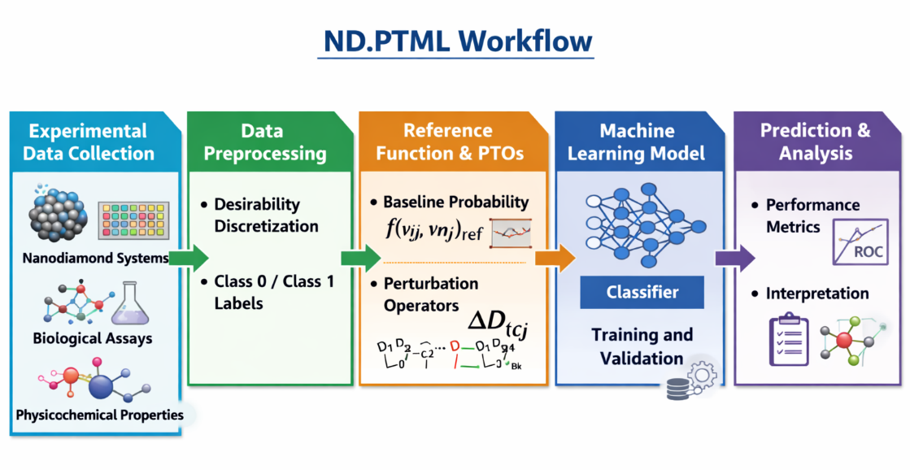
Figure SI_01. Schematic representation of the ND.PTML workflow.
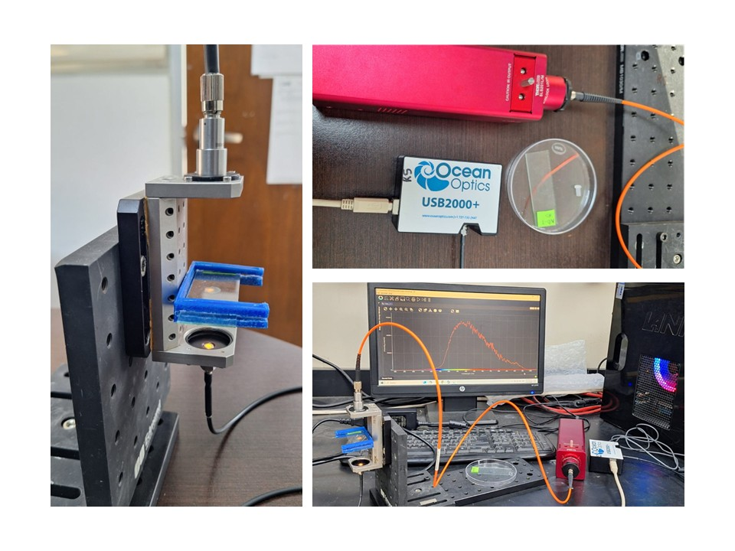
Figure SI_02. Custom-built optical bench used in optoelectronic study.

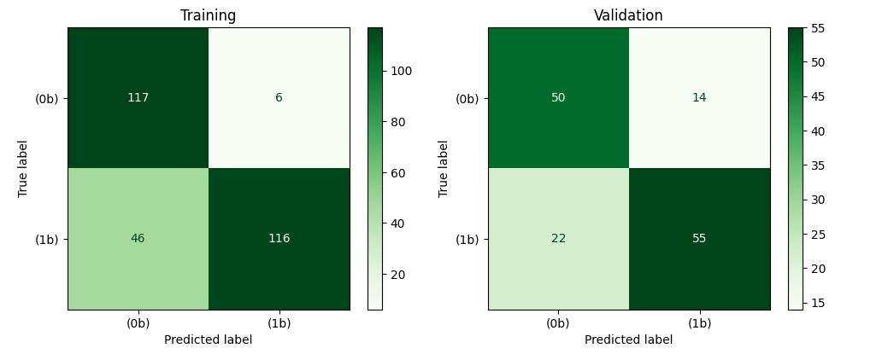
Figure SI_03. Confusion matrices of the optimized Decision Tree classifier for the training and validation datasets.
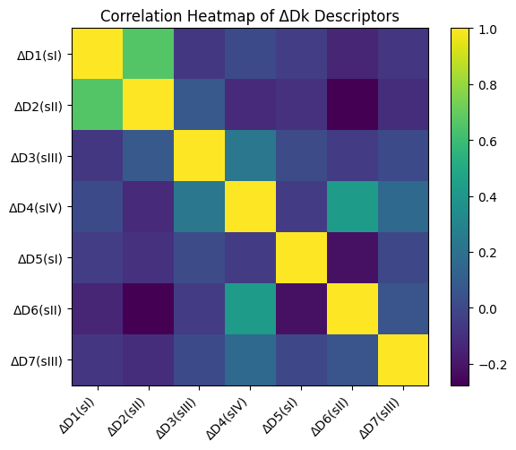
Figure SI_04 Correlation heatmap of the ΔDk descriptors used as input variables in the ND.PTML model.

List of abbreviations
AI Artificial Intelligence
AUROC Area Under Receiver Operating Characteristic
DLS Dynamic Light Scattering
DT Decision Tree
FND Functionalized Nanodiamond
GB Gradient Boosting
IF Information Fusion
kNN k-Nearest Neighbors
LDA Linear Discriminant Analyses
ML Machine Learning
ND Nanodiamond
NP Nanoparticle
PT Perturbation Theory
PTOs Perturbation Theory Operators
RF Radom Forest
SEM Scanning Electron Microscopy

References
(1) Li, Y.; Li, H.; Pickard, F. C.; Narayanan, B.; Sen, F. G.; Chan, M. K. Y.; Sankaranarayanan, S. K. R. S.; Brooks, B. R.; Roux, B. Machine Learning Force Field Parameters from Ab Initio Data. J. Chem. Theory Comput. 2017, 13 (9), 4492–4503. https://doi.org/10.1021/acs.jctc.7b00521.
(2) Xia, R.; Kais, S. Quantum Machine Learning for Electronic Structure Calculations. Nat. Commun. 2018, 9 (1), 4195. https://doi.org/10.1038/s41467-018-06598-z.
(3) Na, G. S.; Chang, H.; Kim, H. W. Machine-Guided Representation for Accurate Graph-Based Molecular Machine Learning. Physical Chemistry Chemical Physics 2020, 22 (33), 18526–18535. https://doi.org/10.1039/D0CP02709J.
(4) Nocedo-Mena, D.; Cornelio, C.; Camacho-Corona, M. D. R.; Garza-González, E.; Waksman De Torres, N.; Arrasate, S.; Sotomayor, N.; Lete, E.; González-Díaz, H. Modeling Antibacterial Activity with Machine Learning and Fusion of Chemical Structure Information with Microorganism Metabolic Networks. J. Chem. Inf. Model. 2019, 59 (3), 1109–1120. https://doi.org/10.1021/acs.jcim.9b00034.
(5) Bahman, A. M.; Pradeep, E.; Said, Z.; Sharma, P. Prognostic Machine Learning Models for Thermophysical Characteristics of Nanodiamond-Based Nanolubricants for Heat Pump Systems. Energy and AI 2024, 18, 100453. https://doi.org/10.1016/j.egyai.2024.100453.
(6) Santana, R.; Zuluaga, R.; Gañán, P.; Arrasate, S.; Onieva, E.; González-Díaz, H. Designing Nanoparticle Release Systems for Drug–Vitamin Cancer Co-Therapy with Multiplicative Perturbation-Theory Machine Learning (PTML) Models. Nanoscale 2019, 11 (45), 21811–21823. https://doi.org/10.1039/C9NR05070A.
(7) Santana, R.; Zuluaga, R.; Gañán, P.; Arrasate, S.; Onieva, E.; González-Díaz, H. Predicting Coated-Nanoparticle Drug Release Systems with Perturbation-Theory Machine Learning (PTML) Models. Nanoscale 2020, 12 (25), 13471–13483. https://doi.org/10.1039/D0NR01849J.
(8) Santana, R.; Zuluaga, R.; Gañán, P.; Arrasate, S.; Onieva, E.; Montemore, M. M.; González-Díaz, H. PTML Model for Selection of Nanoparticles, Anticancer Drugs, and Vitamins in the Design of Drug–Vitamin Nanoparticle Release Systems for Cancer Cotherapy. Mol. Pharm. 2020, 17 (7), 2612–2627. https://doi.org/10.1021/acs.molpharmaceut.0c00308.
(9) Hill, T.; Lewicki, P. Statistics: Methods and Applications: A Comprehensive Reference for Science, Industry, and Data Mining; Tulsa, O., Ed.; StatSoft, Inc: United Kingdom, 2006. https://doi.org/10.1016 / B978-0-323-03707-5.50024-3.

